Empirical Formula Determination

Carbon dioxide (CO₂), water (H₂O) and ammonia (NH₃) are three of many compounds with which you are familiar. Have you ever seen a compound with a formula such as Na_{2.3}Cl_{3.9}? In fact, such a formula is impossible. Only whole atoms, not fractions of atoms, react with each other to form products. Also, although elements may react in different proportions to form more than one compound, the proportions of the atoms in those compounds will always be a ratio of small whole numbers. An empirical formula gives the simplest whole-number ratio of the different atoms in a compound. For example, while the molecular formula for hydrogen peroxide is H₂O₂, the simplest whole number ratio of hydrogen and oxygen atoms can be expressed as HO. Thus the empirical formula of hydrogen peroxide is HO.

In this lab, you will experimentally determine the percent composition and empirical formula of magnesium oxide, the compound formed when magnesium metal reacts with oxygen. When ignited, magnesium metal will react with oxygen and nitrogen in air to form the products magnesium oxide and magnesium nitride. The magnesium nitride will be removed by adding water to the combustion residue and then heating.

Materials:
Safety goggles Bunsen burner Crucible tongs Crucible, with lid
Ring stand Ring support Clay triangle Distilled water (dH₂O)
25 cm of magnesium ribbon, Mg Centigram balance (to 0.01g)

Pre-Lab Questions:
A piece of iron weighing 85.65 g was burned in air. The mass of the iron oxide produced was 118.37 g.
- Use the law of conservation of mass to calculate the mass of oxygen that reacted with the iron.
- Use the molar mass of oxygen to calculate the number of moles of oxygen atoms in the product.
- Use the molar mas of iron to convert the mass of iron used to moles of iron.
- Use the ratio between the number of moles of iron atoms and number of moles of oxygen atoms to calculate the empirical formula of iron oxide.

Safety:
- The crucible will become very hot and could cause severe burns if not handled properly.
Only handle the crucible with tongs until the crucible is completely cooled.
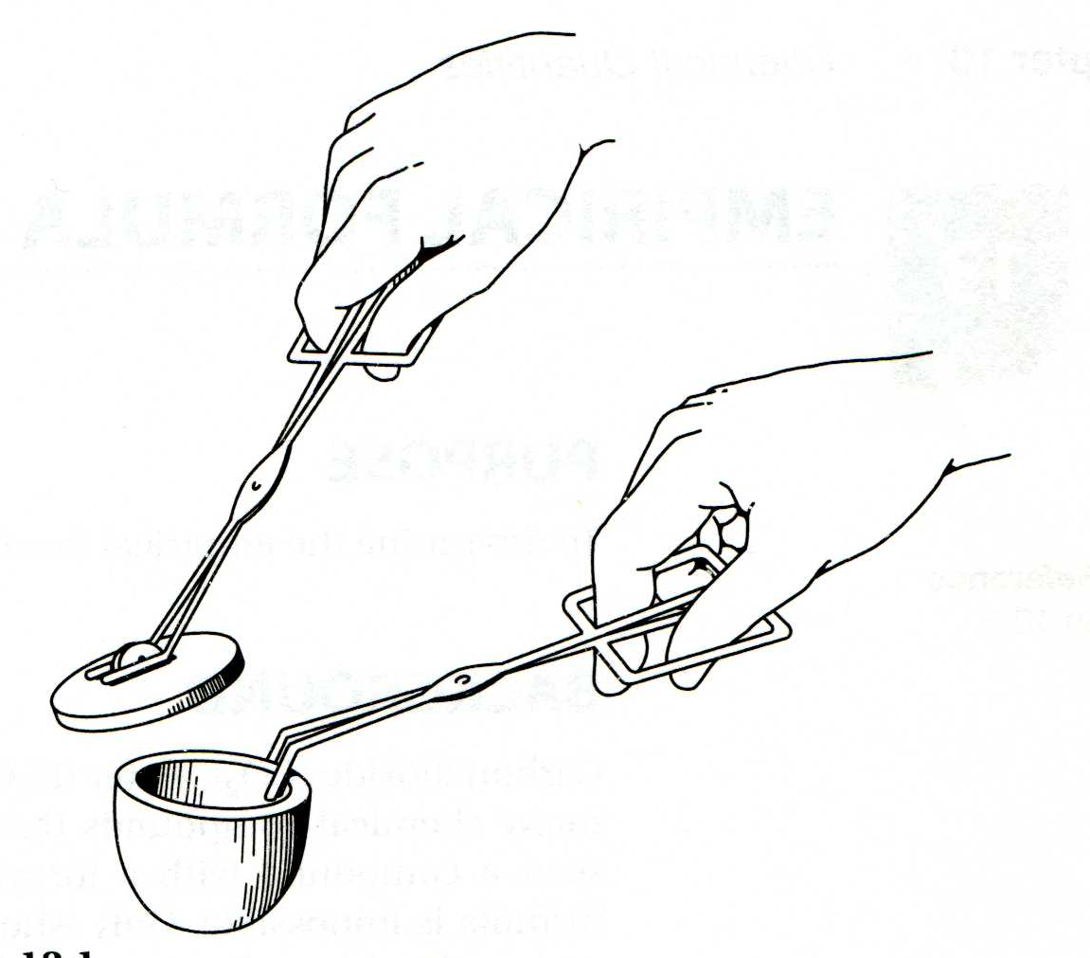
- Do not look directly at the burning magnesium.
- Do not inhale the smoke produced.
- Do not lean directly over the crucible.

Procedure:

- Wipe out the crucible with a paper towel.
- Practice lifting the crucible lid from the crucible with the tongs as shown to the right.
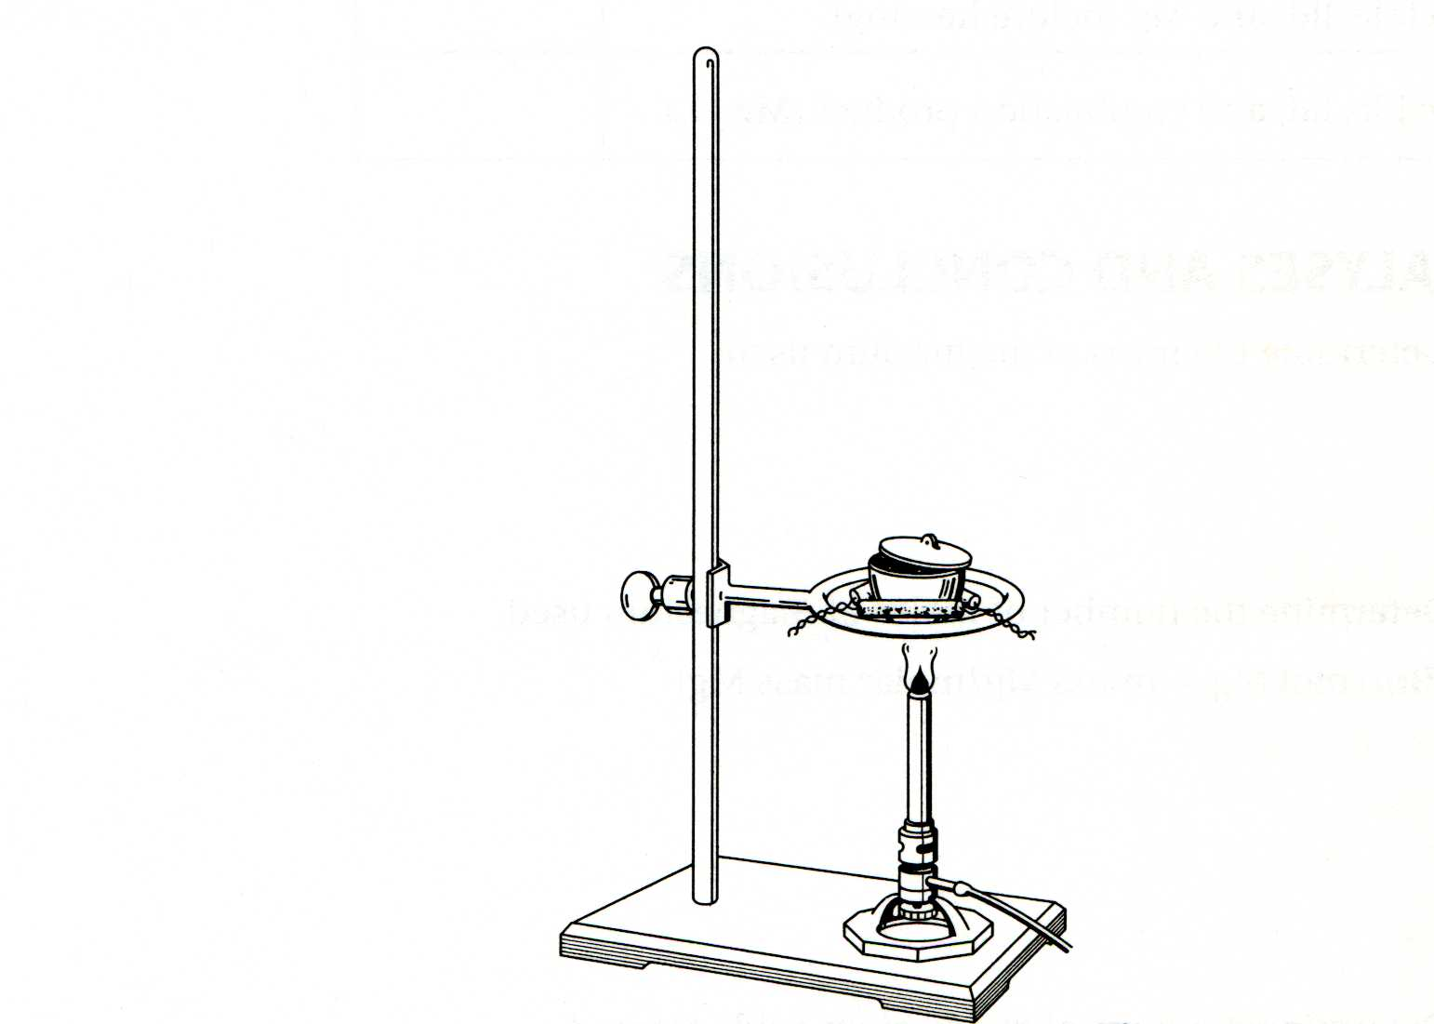
- Set up your ring stand and triangle so that bottom of crucible sitting in the clay triangle is about 1 cm above the Bunsen burner.
- Heat the open crucible for about 5 minutes in the ring stand to drive off any moisture that might be in the crucible, and then let it cool completely.
- Measure the combined mass of the crucible and lid to the nearest 0.01 gram and record.
- Wearing gloves, coil the magnesium around a pencil to obtain a loose ball of metal and place it in the bottom of the crucible. Measure and record the mass of the crucible, lid and magnesium to the nearest 0.01 gram.
- Place the covered crucible in the clay triangle, light the Bunsen burner and heat the crucible in the hottest part of the flame. After 3 minutes, use crucible tongs to carefully lift the lid a small amount. This will allow air to enter the crucible. Once the magnesium ignites, some smoke will be produced. Immediately replace the lid (using tongs) and continue heating.
Blue inner cone of flame should be touching the crucible.
Caution: Do not look directly at the burning magnesium.
Caution: Do not breathe the fumes or lean directly over the top of the crucible.
- After 3 minutes, again lift the crucible lid a small amount. Replace the lid once the metal starts to ignite or the amount of smoke increases significantly.
- Continue heating the crucible for a total of 15 minutes. Approximately every 3 minutes, again carefully lift the crucible lid to allow air to enter, allowing the magnesium to briefly ignite. Immediately replace the lid.
Caution: Do not lean over the top of the crucible. Do not look directly at the burning magnesium.
- After 15 minutes, turn off the gas source and allow the crucible to cool completely.
- To the cooled crucible, add about 10 drops of distilled water. Make sure to wet the entire surface of the sample, not just one spot. Notice if any smell is produced. (hint: You should smell a little ammonia.)
- Warm the open crucible containing the damp sample using a gentle flame for a minute or so, then heat it moderately strongly for about 10 minutes. The crucible need not become red hot for this phase of the experiment, and the cover is not needed for this heating.
- After 10 minutes, turn off the gas source and again allow the crucible to cool completely.
- Measure and record the combined mass of the crucible, lid and magnesium oxide to the nearest 0.01 gram.
- After final weighing, check to see if the reaction is complete. The magnesium metal should be wholly converted to a light gray powder, magnesium oxide. Using a pencil, poke the gray material and record the appearance (color) and consistency. If completely reacted, the magnesium oxide should crumble easily. Note if any ribbon-like material remains (unreacted magnesium metal). Estimate the percent reaction completion and record.
- Follow your teacher’s instructions for proper clean up and disposal of the materials.

Data Table:
Item | Mass (g)
empty crucible and lid
crucible, lid and Mg (before heating)
crucible, lid and combustion product (Mg_{x}O_{y})

Estimated % completion of reaction: _____ % Color/consistency of product: _____________________

Post Lab Questions: (Show all calculations!)

- Determine the mass and number of moles of magnesium used.
- Determine the mass of magnesium oxide formed.
- Determine the mass and number of moles of oxygen that combined with the magnesium.
- Calculate the ratio between the number of moles of magnesium used and the number of moles of oxygen in the product. What is the empirical formula of magnesium oxide?
- Write a balanced chemical equation for the formation of magnesium oxide from magnesium metal and oxygen gas. Write a similar equation for the formation of magnesium nitride from magnesium metal and nitrogen gas. Include phases of reactants and product.
- Adding water to magnesium nitride produces magnesium hydroxide and ammonia gas. Heating the magnesium hydroxide produces magnesium oxide and water vapor. Write balanced chemical equations.
- Calculate the percent error in your determination of the magnesium:oxygen mole ratio, using the accepted calculated value for magnesium oxide.

% error = | accepted value – experimental value | x 100%
accepted value

- The mass of oxygen was determined by subtraction. Would extra mass other than Mg_{x}O_{y} in the crucible at experiment’s end cause the “mass of oxygen” to be too high or too low? Explain.
- If the experimental Mg:O ratio is too low, there was too much oxygen relative to magnesium. If the Mg:O ratio is too large, there was too little oxygen relative to magnesium (or too little weight at experiment’s end, which registers as too little oxygen). In each case below, decide whether the situation would lead to a calculated ratio of too much oxygen (Mg:O < 1) or too little oxygen (Mg:O > 1), and explain your reasoning.
- Reaction not getting hot enough, resulting in unreacted magnesium at the end.
- Putting in more water than needed for the last reaction, and then not drying out this excess water.
- Forgetting to weigh the lid along with the crucible and contents at the end.
- Letting a lot of dense white smoke escape from the crucible during the burning reaction.
- Mg₃N₂ forms in a side reaction, adding N mass in 3:2 ratio (Mg:N) instead of O mass in a 3:3 ratio (Mg:O).
- Specify at least two observed sources that explain your group’s experimental error. Be specific - how does each affect your calculated amounts of oxygen or magnesium? How does it affect the calculation of Mg_{x}O_{y}?
- How does your data and calculation of Mg_{x}O_{y} compare with those of all other lab groups?
- Calculate the percent composition of Mg_{x}O_{y} using your group data. Compare these values to the expected values and account for any differences. Show all work.
- How can your data be used to calculate a theoretical percent completion? What assumption must you make? How does this theoretical value compare with your observed value?

